Assignment 4 UHF RFID Applications

**1.** RFID天线按照设计工艺的不同可以划分为线圈型(Coil)、 微带贴片型 (Microstrip

)和偶极子型(Dipole Antenna)三种。其中低频和高频频段的RFID系统一般采用 线圈型

天线。在远距离耦合(Long Distance Coupling)的RFID应用系统中，最常用的是 微带

天线。

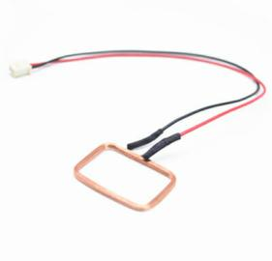 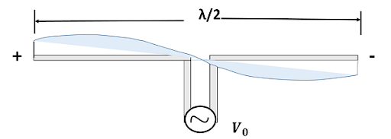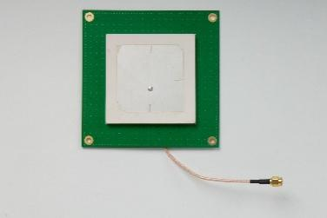

**Fig 1 Coil\Dipole\Microstrip Antenna**

**2.** 极化(Polarization)方式是天线的重要参数之一，基本的单极化方式包括垂直极化和 水平极化 ，其中最常用的极化是 正交极化

。( Find out more watching: Inside Wireless_ Antenna Polarization.mp4)

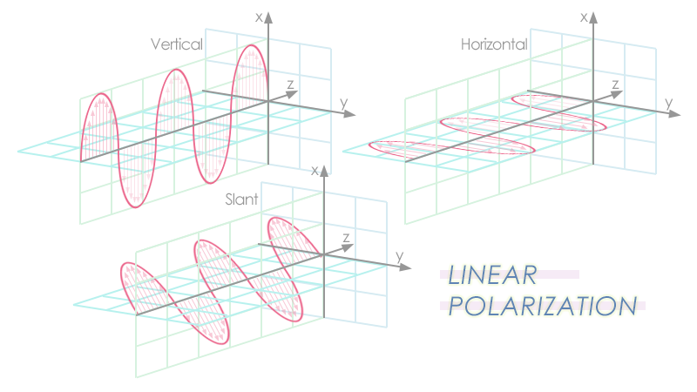

**Fig 2 Polarization**

**3.** 物联网名称解析服务(ONS: Object Name Service)和物联网信息发布服务(EPCIS: Electronic Product Code Information Services)是物联网的两个组成部分，主要完成信息的传输和管理功能。其中 物联网信息发布服务 负责对物联网中的信息进行发布，而 物联网名称解析服务 则负责将电子标签解析成其对应的网络资源地址。现在物联网比较成熟的名称解析服务和信息发布服务是EPC系统，EPC系统名称解析服务成为 EPCONS 。（Ranasinghe, Damith & Leong, Kin & Ng, Mun & Engels, Daniel & Cole, Peter. (2005). A distributed architecture for a ubiquitous item identification network.）

4. Explain the meaning of UHF, Microstrip Antenna, RFID Middleware.

UHF（超高频）:

In the radio spectrum, a radio frequency second only to the highest frequency band, which refers to the frequency in the frequency band of 3 ~ 30 GHz

Microstrip Antenna（微带天线）:

A microstrip antenna is an antenna formed by attaching a thin metal layer as a ground plate on a thin dielectric substrate, making a certain shape of metal patch by photolithography and etching on the other side, and feeding the patch with a microstrip line or coaxial probe.

RFID Middleware（RFID 中间件）:

**"RFID middleware is a message oriented middleware (MOM). Information is transmitted from one program to another or more programs in the form of message. Information can be asynchronous So the sender doesn't have to wait for a response. Message oriented middleware includes not only passing information, but also interpreting data, security, data broadcasting, error recovery, locating network resources, finding cost-effective paths, prioritizing messages and requirements, and extended debugging tools**

5. What is Modulation？List the common digital modulation methods in RFID’s application.( Find out more watching:Digital modulation_ ASK, FSK, and PSK.mp4)

The process of converting a signal to be transmitted into a signal suitable for channel transmission is called modulation

Methods: amplitude shift keying (ask), frequency shift keying (FSK), phase shift keying (PSK) and subcarrier modulation were used in most RFID systems.

6.简述分别画出二进制序列**101101** 的NRZ编码(NRZ 编码:Non-return-to-zero Code，也叫不归零编码)和曼彻斯特码的波形图。(Find out more watching:Manchester Encoding in 2 minutes.mp4) 